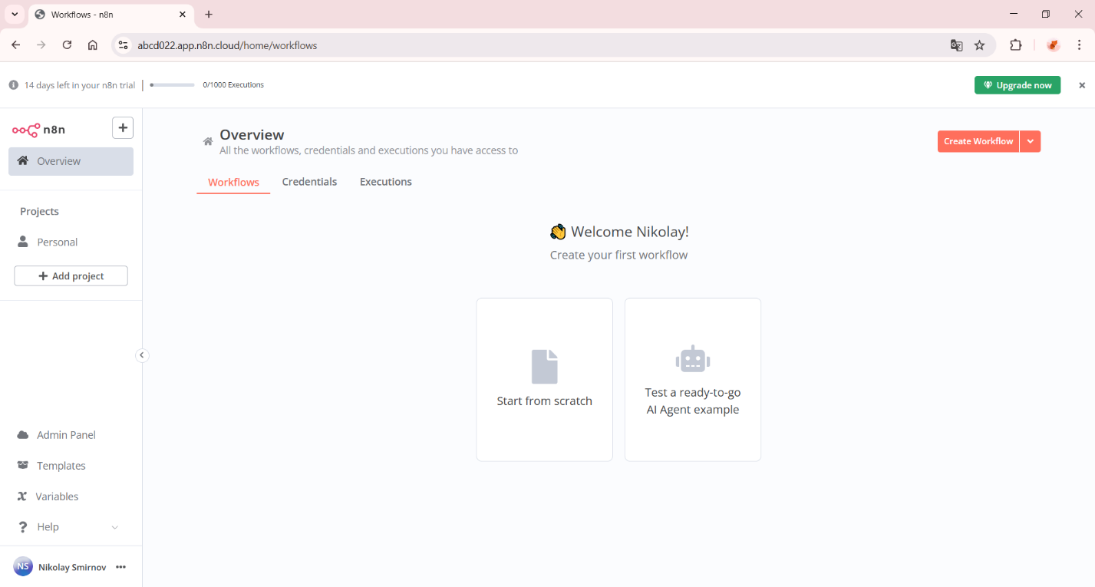
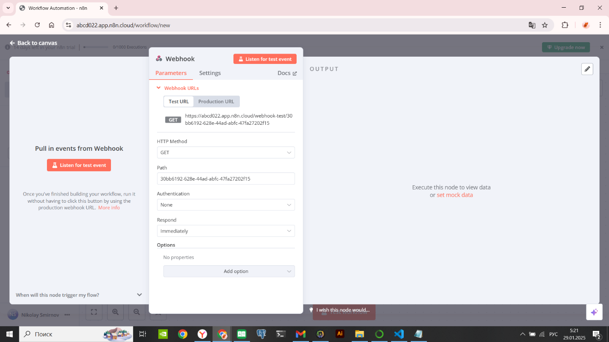
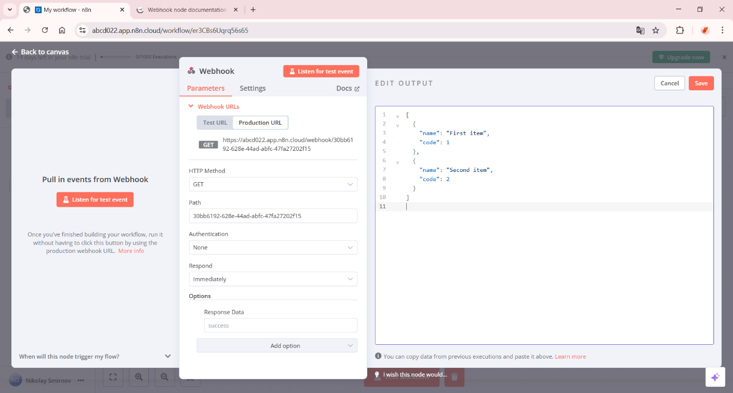
{
"nodes": [
{
"parameters": {
"httpMethod": "POST",
"path": "random-user",
"responseMode": "onReceived",
"responseData": "firstEntryJson",
"options": {}
},
"name": "Webhook",
"type": "n8n-nodes-base.webhook",
"typeVersion": 1,
"position": [200, 300]
},
{
"parameters": {
"url": "https://randomuser.me/api/",
"options": {}
},
"name": "Get Random User",
"type": "n8n-nodes-base.httpRequest",
"typeVersion": 1,
"position": [400, 300],
"credentials": {}
},
{
"parameters": {
"functionCode": "return items[0].json.results[0].dob.age > 18 ? items : [];"
},
"name": "Filter Age > 18",
"type": "n8n-nodes-base.function",
"typeVersion": 1,
"position": [600, 300]
},
{
"parameters": {
"functionCode": "const user = items[0].json.results[0];\nreturn [{\n json: {\n name: `${user.name.first} ${user.name.last}`,\n age: user.dob.age.toString(),\n phone: user.phone,\n gender: user.gender\n }\n}];"
},
"name": "Format User Data",
"type": "n8n-nodes-base.function",
"typeVersion": 1,
"position": [800, 300]
}
],
"connections": {
"Webhook": {
"main": [
[
{
"node": "Get Random User",
"type": "main",
"index": 0
}
]
]
},
"Get Random User": {
"main": [
[
{
"node": "Filter Age > 18",
"type": "main",
"index": 0
}
]
]
},
"Filter Age > 18": {
"main": [
[
{
"node": "Format User Data",
"type": "main",
"index": 0
}
]
]
}
}
}

